Group Project: Reproducible Pipeline for Precision Nutrition Analysis
- CRISP-DM framework for Growth Analysis
NO | PROCESS | DESCRIPTION
1 | Project Understanding
 | Objective | Research Question: Are maternal dietary, socioeconomic, and clinical factors associated with early childhood growth trajectories based on BMI-for-age z scores (zBMI)?  Population: Children aged 24 months (n = 300) in the study cohort with available growth and maternal characteristics.  Exposures: Maternal dietary factors, socioeconomic factors, clinical biomarkers, and gut microbiome  Outcome: zBMI trajectory clusters
 | 1a. What exactly is the problem, the expected benefits? | Inadequate nutrition during early childhood is associated with malnutrition and increased risk of later-life disease development. Identifying maternal factors (dietary, socioeconomic, clinical biomarkers, gut microbiome) that associate with early-life growth patterns could help identify children at risk of malnutrition and later-life adverse health outcomes and help in developing public health and clinical guidelines.  The proposed approach is to use zBMI, adjusted for age and sex according to WHO growth standards, to identify heterogeneous growth patterns and group children by similar growth patterns. Through this, we could design targeted disease prevention strategies and promote healthy dietary practices during gestation and early life.  Expected benefits:  - Better understand how maternal diet and socioeconomic factors influence growth  - Identifying heterogeneous growth trajectories and clustering these zBMI will allow for the detection of subsets of children that may respond differently to our exposures (i.e., maternal dietary, socioeconomic, clinical factors, and gut microbiome)  - Inform precision nutrition strategies and targeted early-life interventions rather than generalized population-based recommendations
 | 1b. How would a solution look like? | Children will be clustered based on their zBMI scores at 24 months, and these clusters will be used to determine whether maternal dietary, socioeconomic, clinical factors, and gut microbiome are associated with zBMI categories.  - A set of distinct child clusters, each characterized by some variables: Maternal dietary factors, Socioeconomic factors; Clinical biomarkers, and Gut Microbiome.  - A visual summary (dendogram) that clearly shows cluster differences in zBMI and associated exposures.  - Interpretation for each cluster, e.g. Cluster A = high Ultra processed score + Low SCFA index + elevated CRP + low Shannon diversity.  Each cluster will be clinically interpreted, e.g. excess adiposity or moderate inflammation. From these analyses, we may be able to extract useful information regarding which factors strongly associate and their directionality, and to establish tailored intervention recommendations.
 | 1c. What is known about the domain? | Early-life growth trajectories are known predictors of later obesity and metabolic disease risk, and maternal nutrition and socioeconomic conditions have been shown to influence early childhood growth and development.  zBMI based on WHO Child Growth Standards are internationally accepted tool for classifying nutritional status in children under 5.
2 | Data Understanding
 | 2a. What data do we have available? | Maternal dietary factors:  - Energy intake (kcal) – continuous  - Fiber intake (g) – continuous  - Protein intake (g) – continuous  - Ultra-processed score – continuous  - Dietary pattern score – continuous  Microbiome factors:  - Firmicutes : Bacteriodetes ratio – continuous  - Shannon diversity – continuous  - SCFA index – continuous  Socioeconomic factors:  - Household income – continuous  - Maternal education (years) – ordinal  Maternal health factors:  - Maternal BMI (kg/m²) – continuous  - Gestational age (weeks) – continuous  Clinical biomarkers:  - Fasting glucose (mmol/L) – continuous  - C-reactive protein (CRP) (mg/L) – continuous  - Alanine aminotransferase (ALT) (U/L) – continuous  Child growth variables:  - Age at 24 months (months) – categorical  - Sex – categorical  - Weight at 0 (birth), 6, 12, and 24 months (kg) – continuous  - Length at 0 (birth), 6, 12, and 24 months (cm) – continuous  - BMI & BMI-for-age z-scores (zBMI) at 24 months – continuous  - Stunted status at 24 months – categorical
 | 2b. Is the data relevant to the problem? | Yes, the provided dataset includes 30 variables representing maternal dietary factors, socioeconomic factors, clinical biomarkers, and gut microbiome, which are possible determinants of growth and metabolic health and are being tested for their association with the outcome of interest (zBMI at 24 months).
 | 2c. Is it valid? Does it reflect our expectations? | The data leveraged is commonly used for clinical and nutritional measures.  However, several potential data quality issues exist, including:  - Missing data  - Implausible age values  - Outliers in zBMI and clinical biomarkers  - Data entry error  The data will need to be evaluated using exploratory analyses (histograms, boxplots, and scatterplots) to assess the distribution of variables, detect outliers, and evaluate if the values reflect realistic biological values. The missingness pattern should be assessed to guide imputation.
 | 2d. Is the data quality, quantity, recency sufficient? | Quantity: The dataset contains 300 observations across 30 variables, providing a reasonable sample for exploratory clustering. However, there is a possibility of clusters with small numbers (e.g. n <30) which underpowered for biological interpretation.  Quality: The dataset appears sufficient for exploratory growth analysis, although there are intentional imperfections (e.g., missing data, implausible values, biological outliers) that will need to be assessed and addressed in the statistical model to improve the reliability of the data.  Recency: Not applicable (mock precision nutrition cohort)
3 | Data Preparation
 | 3a. Which data should we concentrate on? | Maternal dietary factors:  - SCFA index  - Energy intake (kcal)  - Fiber intake (g)  - Protein intake (g)  - Ultra-processed score  - Dietary pattern score  Socioeconomic factors:  - Household income  - Maternal education (years)  Clinical biomarkers:  - Fasting glucose  - C-reactive protein (CRP)  - Alanine aminotransferase (ALT)  Child growth variables:  - Age at 24 months  - Weight at 6, 12, and 24 months  - Length at 6, 12, and 24 months  - BMI-for-age z-scores (zBMI) at 24 months
 | 3b. How is the data best transformed for modelling? | The data will undergo several transformations, including:  Handling skewed data  - If any of the variables are found to be non-normally distributed, appropriate transformations will be applied (e.g., log-transforming data) to try to approximate normality to improve model stability  Handling categorical data  - Categorical data was already transformed into a usable binary system for modelling.  Transforming BMI data  - BMI data was z-score transformed, possibly using the LMS (Lambda-Mu-Sigma) method, adjusting for sex and age to provide a standardized measure to compare to growth charts
 | 3c. How may we increase the data quality? | Data quality can be improved through:  - Identifying and evaluating statistical outliers  Growth data cleaning  - Removing implausible age values (e.g., negative values)  - Applying WHO growth cut-offs to identify biologically implausible zBMI values (values that fall outside of WHO recommendations, 5 $≥$ zBMI $≤$ -5, will be flagged and removed from the dataset). We set our threshold as 5 $≥$ zBMI $≤$ -5, as this has previously been defined as a threshold for data cleaning of impossible zBMI measurements (PMID: 15069916).  - Treat impossible CRP values (negative) and will be recode as missing and applied for imputation or exclude.  Missing data  - Data will be carefully assessed to determine if the values are missing completely at random, missing at random, or missing not at random  - Any missing values will be assessed to determine if it is more appropriate to remove the entire record (deletion) or replace missing values using estimates (imputation) either by using mean/median imputation (replacing the missing values with the mean of the column), mode imputation (replacing the missing value with the most common, i.e., mode, value of the column) or using K-Nearest Neighbors (using KNN algorithm to find similar records and using their values to fill in missing data)  - If too many values are missing from a column, the variable may be omitted from analysis entirely
4 | Modelling
 | 4a. What kind of model architecture suits the problem best? | Growth trajectory analysis will be used to identify groups of children (i.e., clusters) with similar zBMI trajectory patterns across timepoints (0, 6, 12, and 24 months).  An unsupervised clustering is most appropriate, given the goal of identifying naturally occurring subgroups of children based on their zBMI trajectories and associated variables.  Distance metrics will measure similarity between individuals.
 | 4b. What is the best technique/ method to get the model? | Clustering approaches such as k-means or hierarchical clustering will be used to identify distinct trajectory groups.  - K – Means: assign each child to the nearest centroid.  - Hierarchical clustering: build a dendogram to explore natural groupings without a fixed k.  The ideal number of clusters will be identified using statistical methods, such as the elbow method or silhouette score. Regression models will then evaluate associations between maternal factors and trajectory membership.
 | 4c. How good does the model perform technically? | Model performance will be evaluated using cluster validation metrics such as silhouette scores and examination of regression model assumptions.
5 | Evaluation
 | 5a. How good is the model in terms of project requirements? | The model will be evaluated based on its ability to identify biologically meaningful growth patterns and whether maternal factors significantly explain differences in trajectory groups.  Evaluation of the clustering approach will be assessed by:  - Cluster tendency analysis (Hopkins statistic and PCA)  - Silhouette score  - Within-cluster variance  - Visualization of trajectory patterns  Evaluation of the regression models will be assessed by:  - R²  - Residual diagnostics  - Statistical significance of predictors (i.e., maternal dietary, socioeconomic, and clinical factors)
 | 5b. What have we learned from the project? | The analysis will provide insight into how maternal diet, socioeconomic conditions, maternal health, and gut microbiome may influence early childhood growth trajectories. Identifying these associations may help inform targeted early-life nutrition interventions.  Precision nutrition insights from integrating multiple data domains (diet, gut microbiome, clinical, and socioeconomic) rather than single variables alone.  Reproducibility is essential for transparent science and further research.
6 | Deployment
 | 6a. How is the model best deployed? | The model could be used as a screening tool to identify maternal dietary, socioeconomic, clinical factors, and gut microbiome associated with unfavorable child growth trajectories. In clinical or public health settings, such information could help guide targeted nutritional counselling during pregnancy and early childhood to support healthy growth patterns. Ethical considerations for its implementation will also be made, particularly if any socioeconomic factors are found to be strongly associated with zBMI trajectories.  The reproducible R pipeline in GitHub ensures any clinical site could re-run the same pipeline.
 | 6b. How do we know that the model is still valid? | Model validity would require testing the model on a new dataset to determine if similar growth patterns and associations are observed in a different population (i.e., using a test dataset that is independent of the training dataset).  However, some limitations will exist, including potential residual confounding, measurement error in dietary reporting, and limited generalizability beyond the study cohort.  Data pipeline integrity will ensure that any changes to WHO cut-off parameters or imputation technique are tracked, reproducible, and reviewable by collaborators and the instructor.
7 | What is your goal?
8 | Which is the population/cohort that  you are using?
9 | Data structure/properties:
10 | Gold Standard:

- Growth Analysis Component
- Preprocessing Data
Data Summary
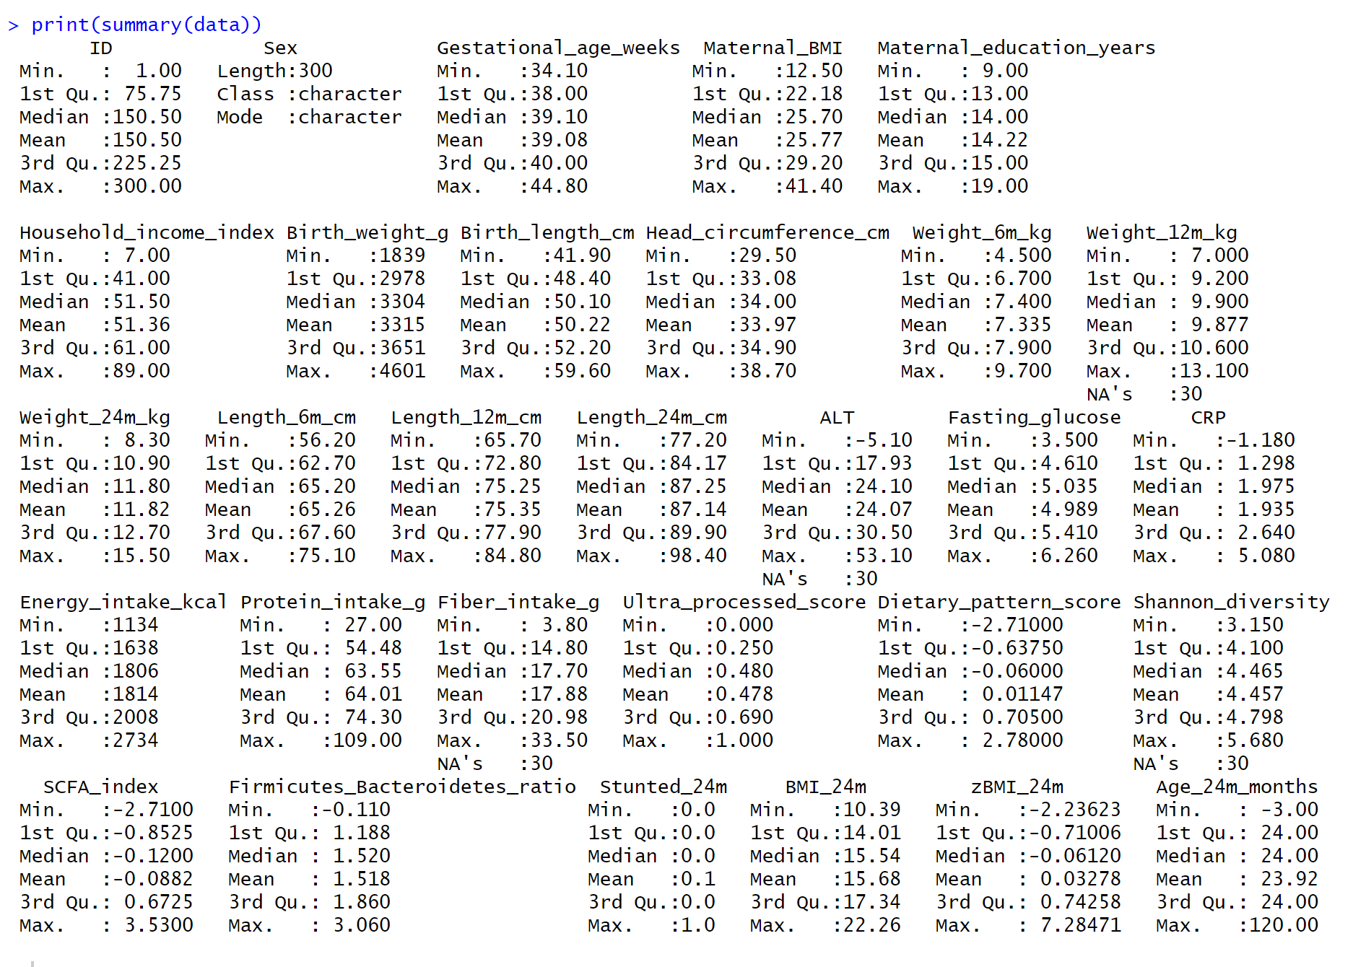
Missing summary:
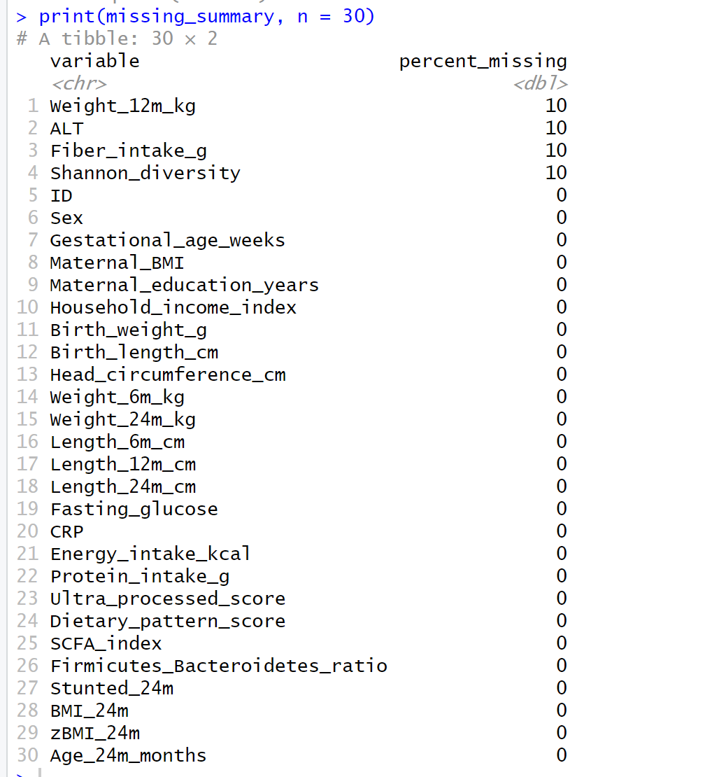
Missingness Plot:
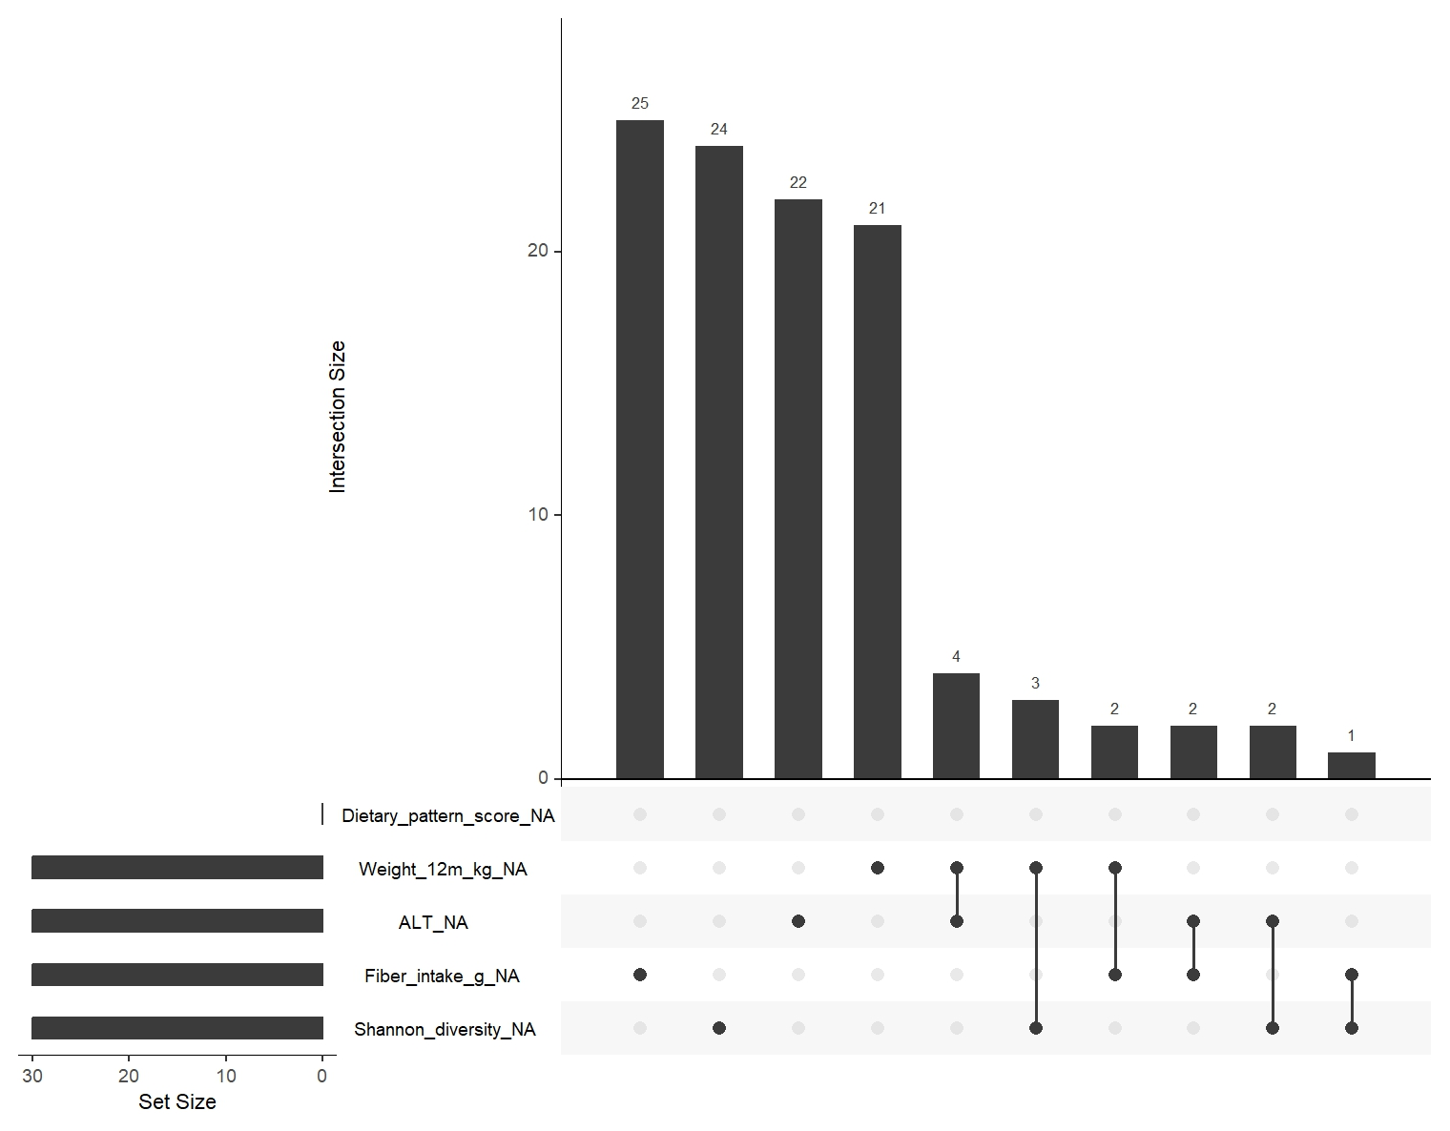

it shows how many observations share the same missingness pattern:
Bar | Missing Pattern | Count
First (25) | Missing in Fiber intake | 25
Second (24) | Missing in Shannon Diversity | 24
Third (22) | Missing in ALT | 22
Fourth (21) | Missing in Weight in 12 months | 21
Fifth (4) | Missing in Weight 12 months and ALT altogether | 4
Sixth (3) | Missing in Weight 12 months and Shannon Diversity | 3
Seventh (2) | Missing in Weight 12 months and Fiber intake | 2
Eight (2) | Missing in ALT and Fiber intake | 2
Ninth (2) | Missing in ALT and Shannon Diversity | 2
Tenth (1) | Missing in Fiber intake and Shannon Diversity | 1
- Clean zBMI (WHO cut-offs)
- Identify 24-months Pattern
- Describe Variability
- Clustering Tendency
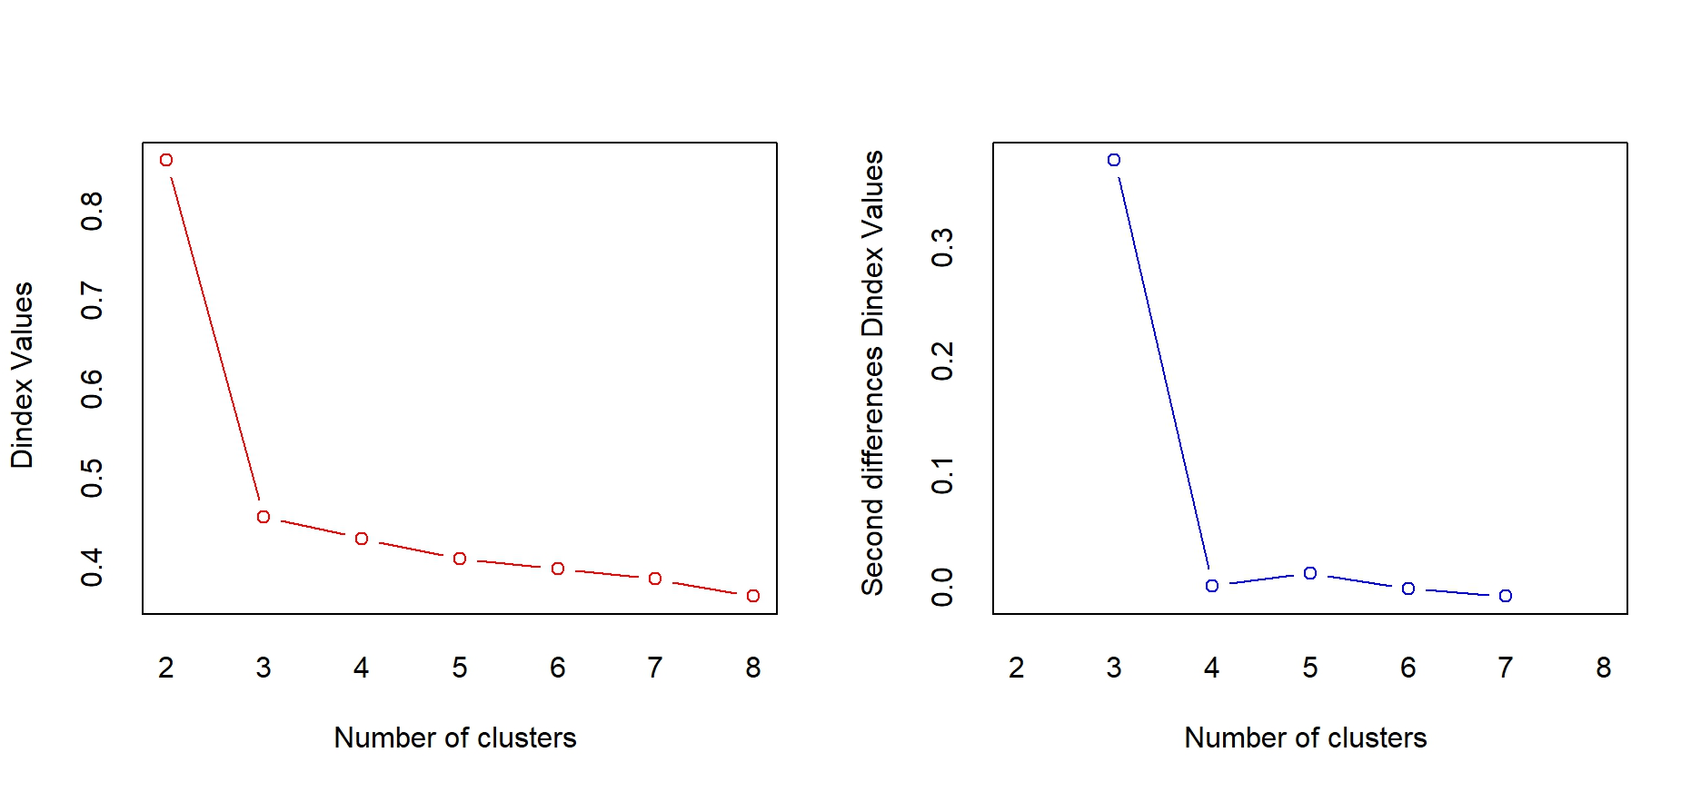
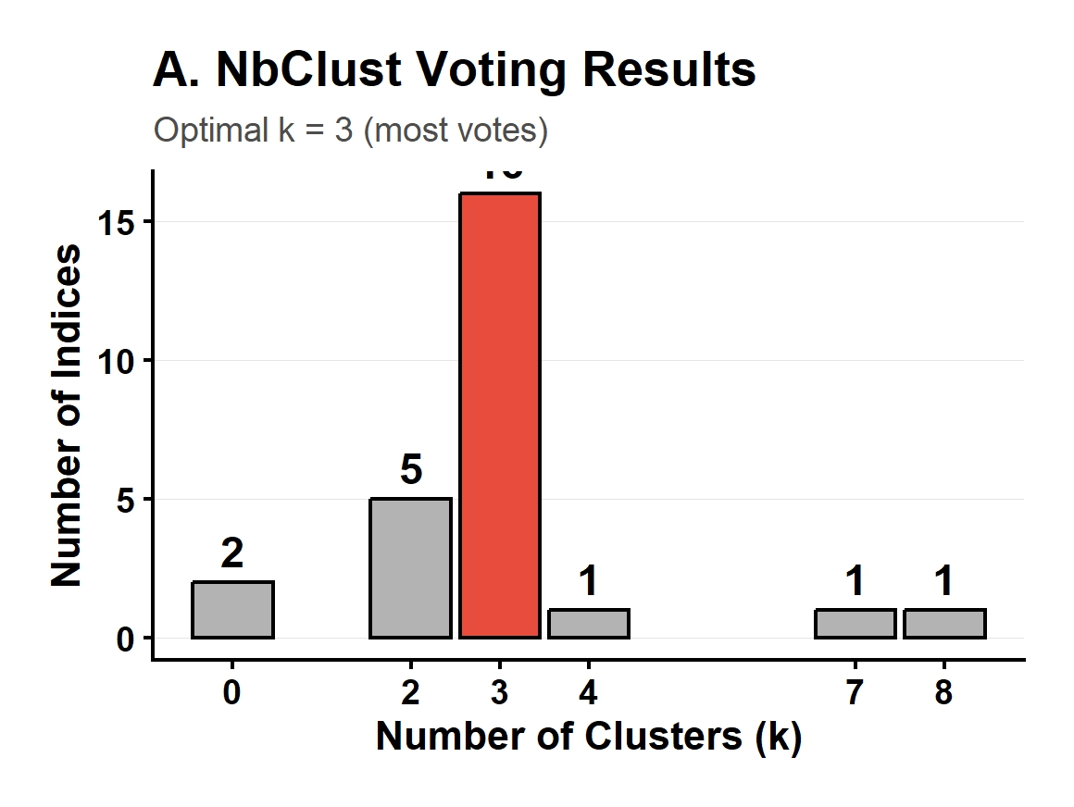
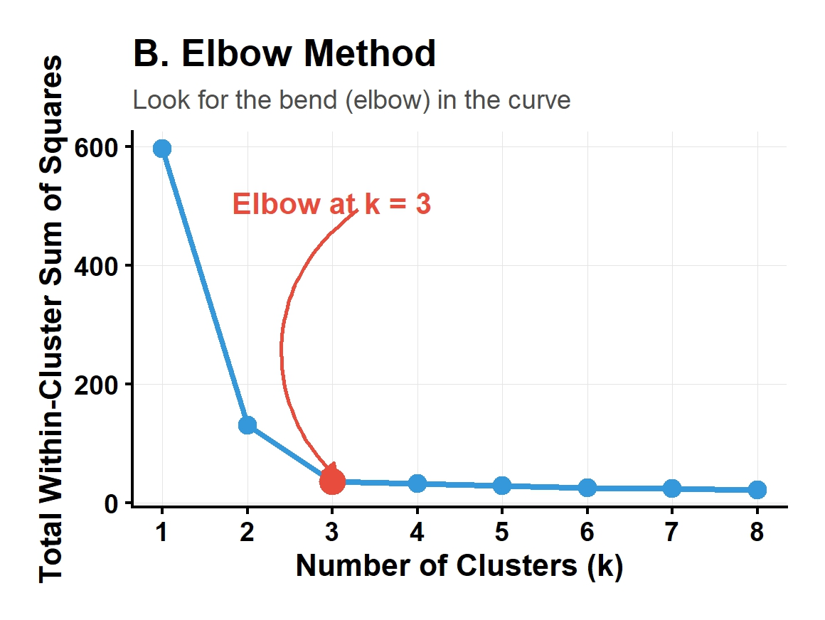
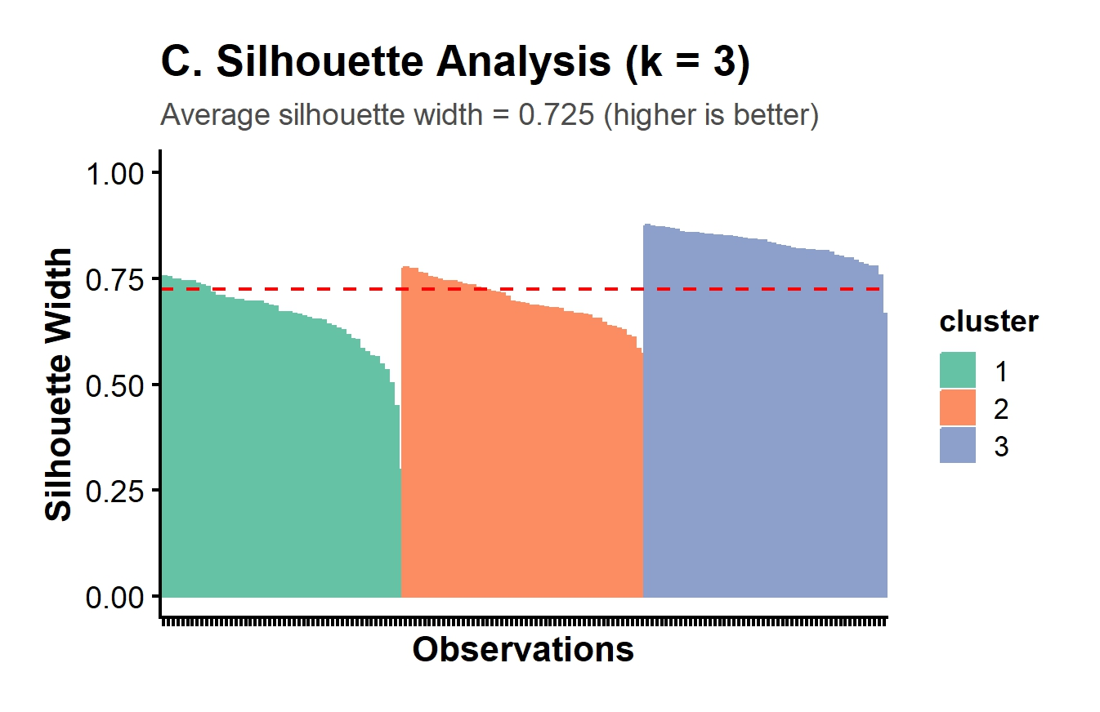
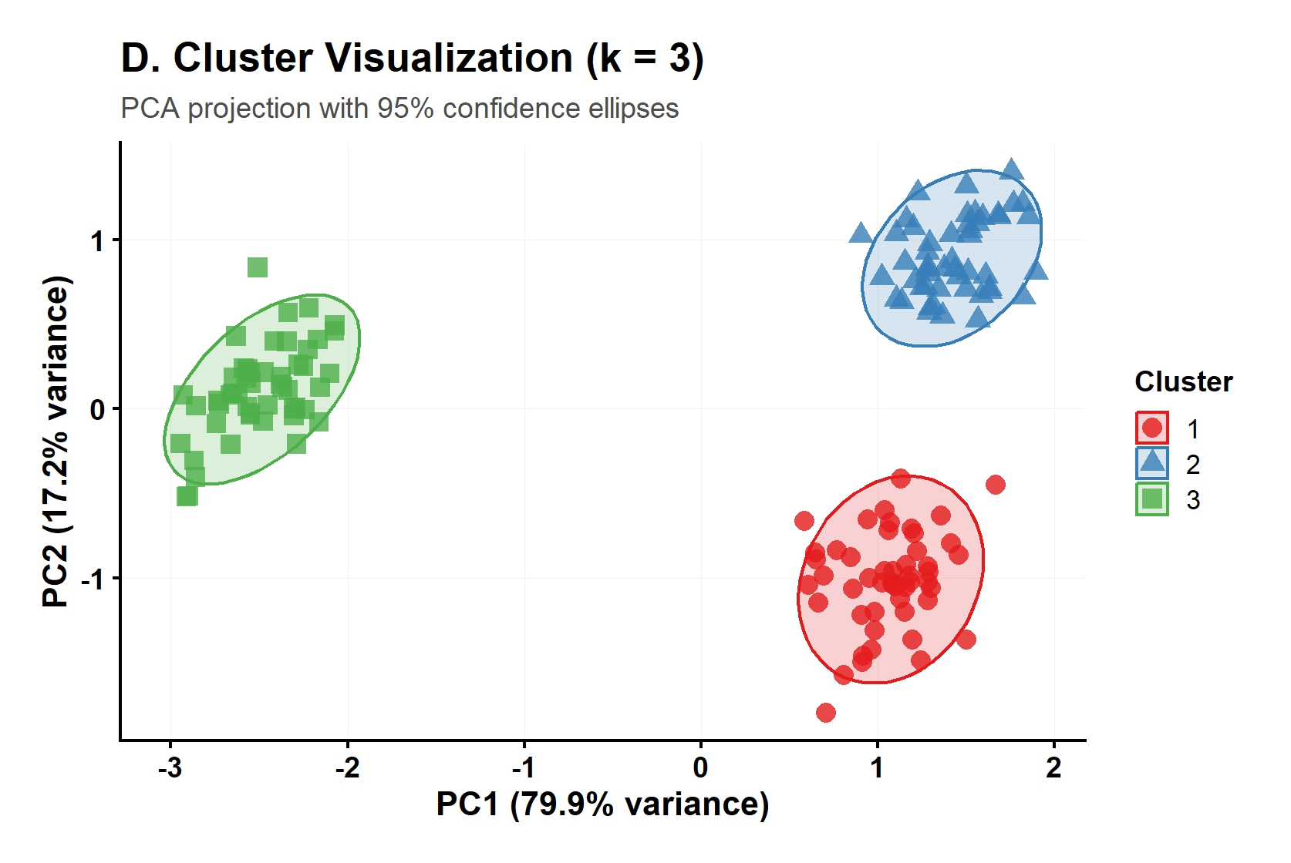
- Comparison of Clustering

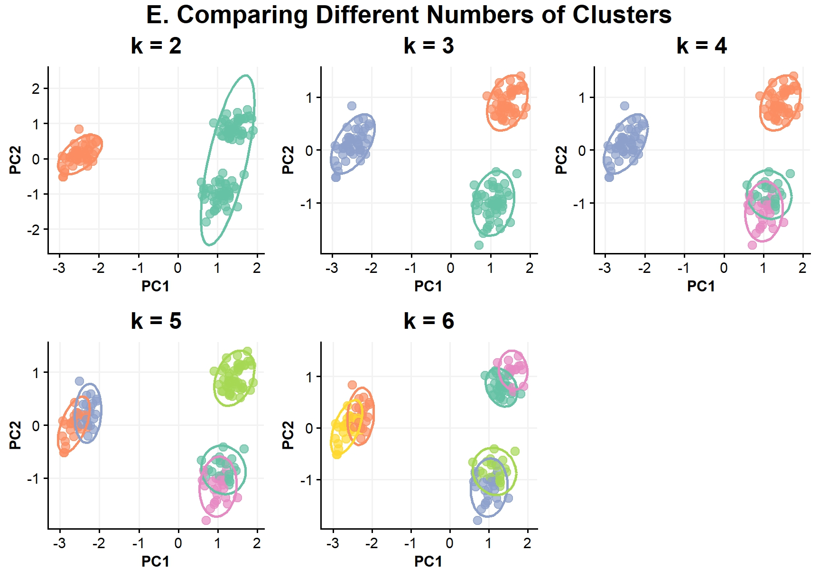
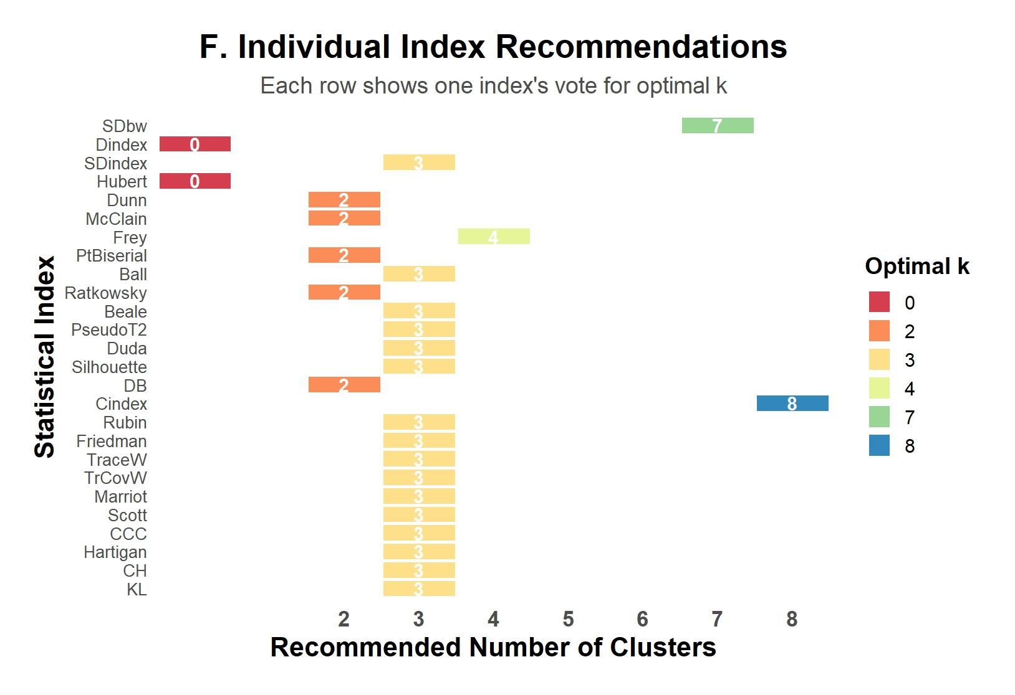
- Heterogeneity
- Biological Plausability
- Clear Visual
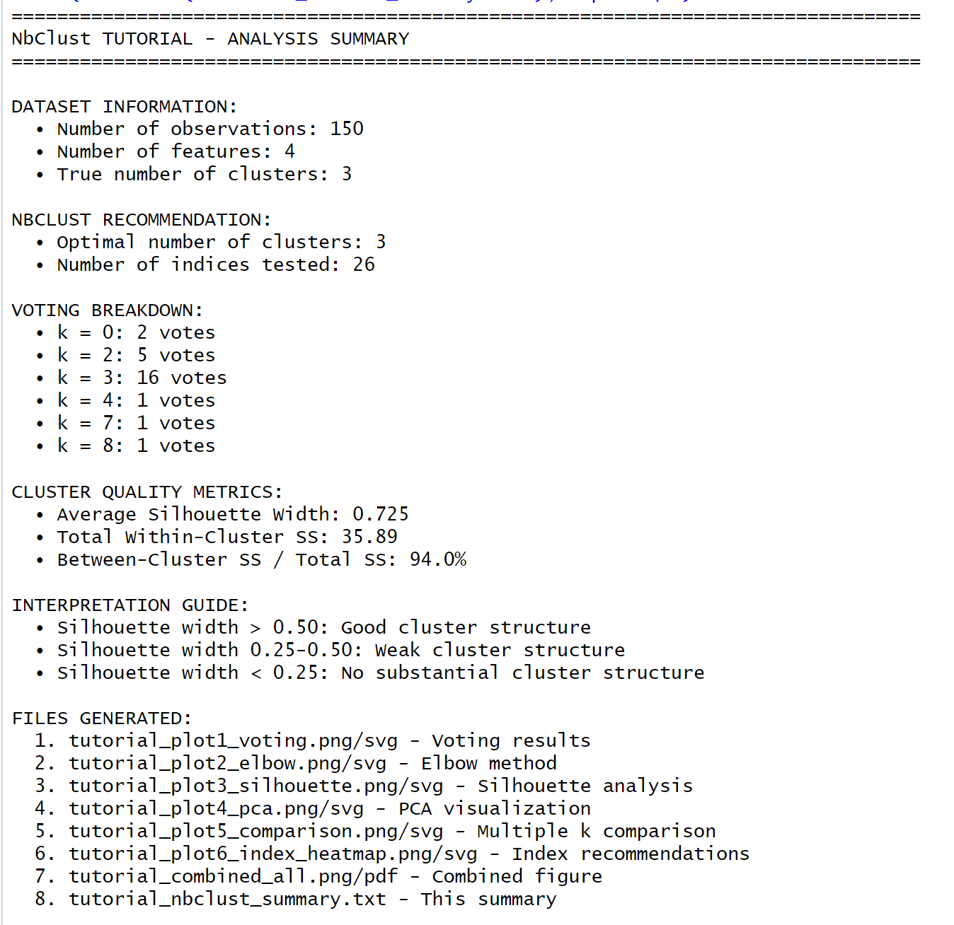

- Distance Computation
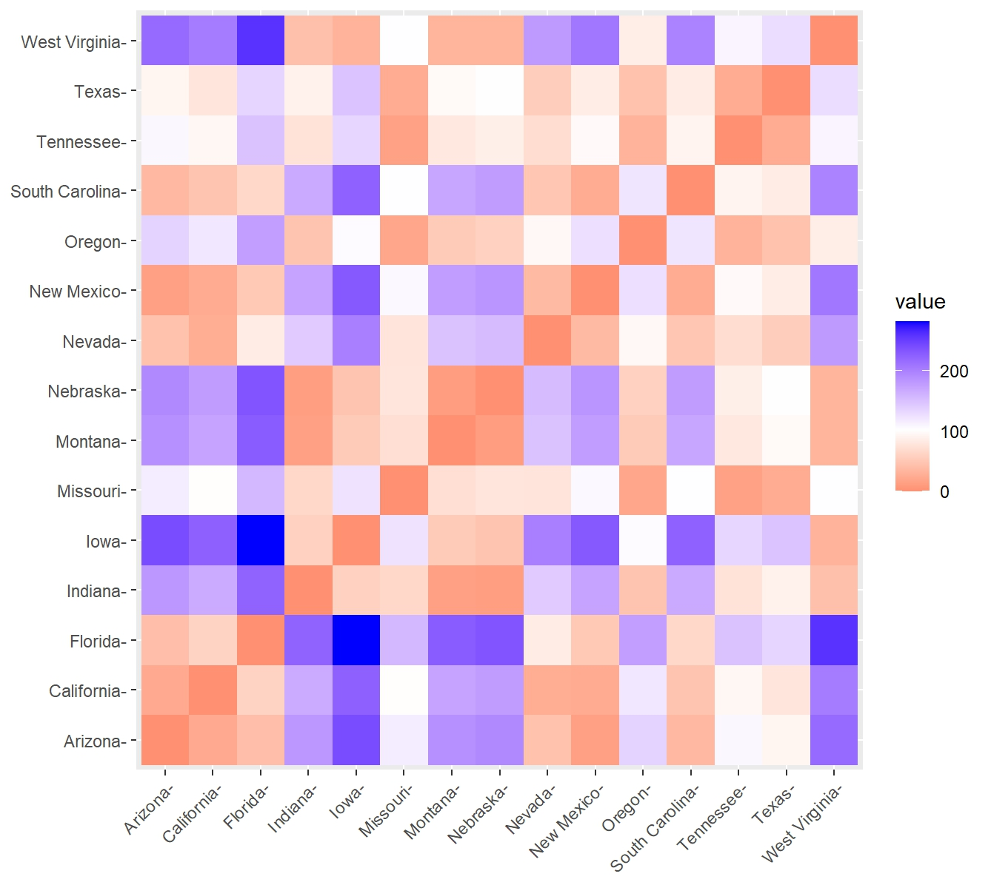
Euclidian

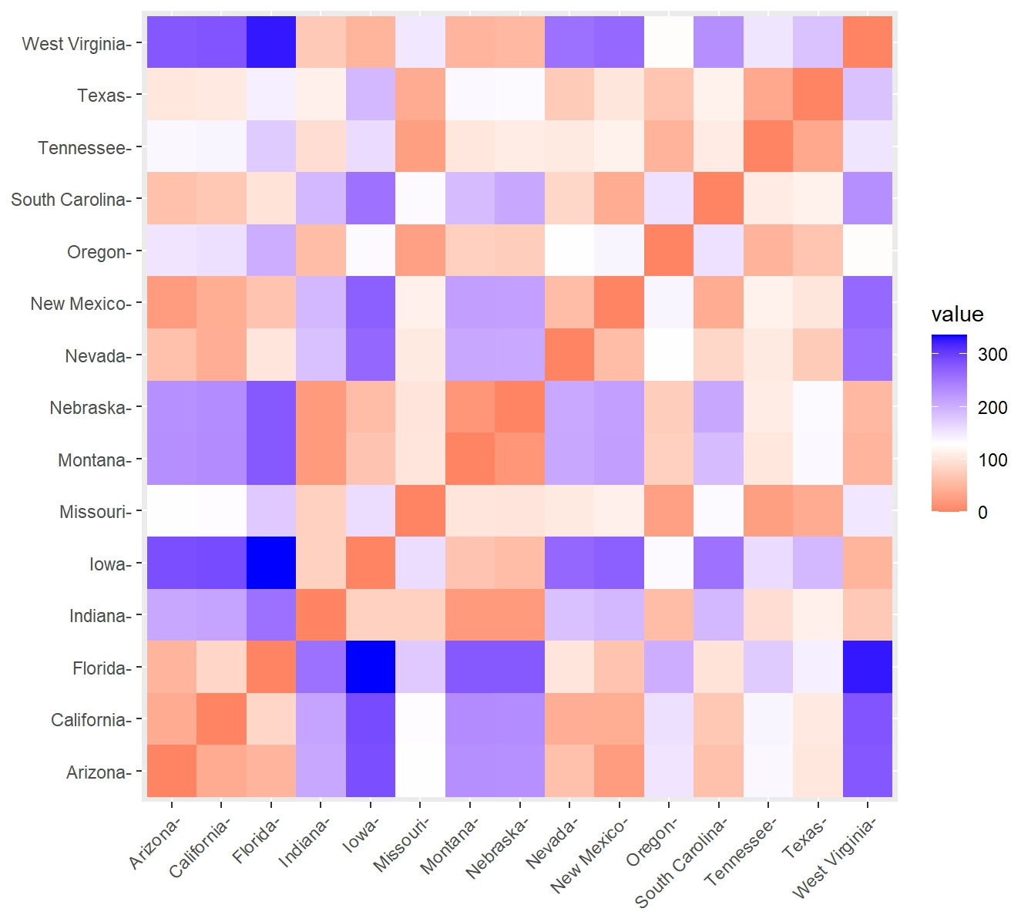
Manhattan

- Clustering
- Clustering Validation
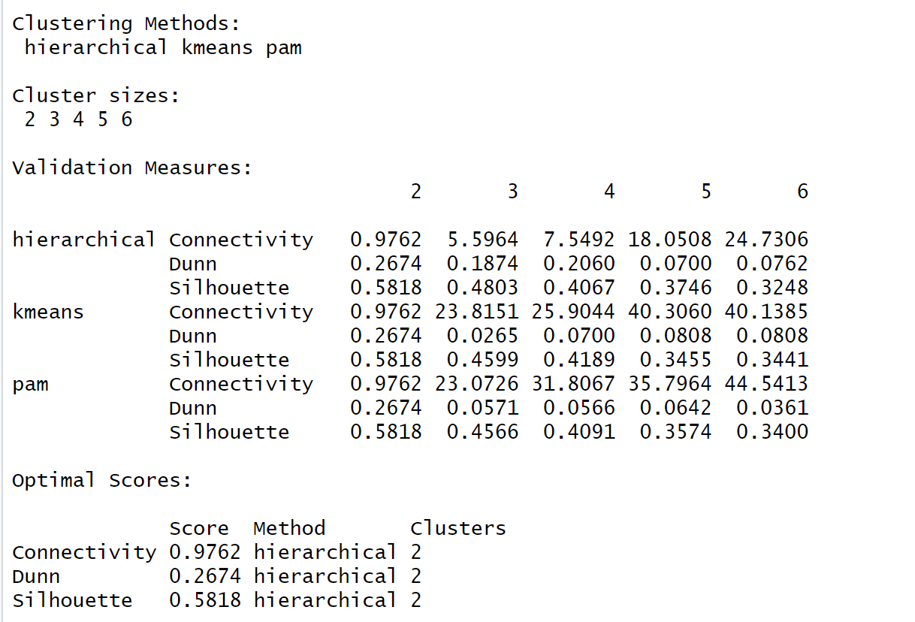

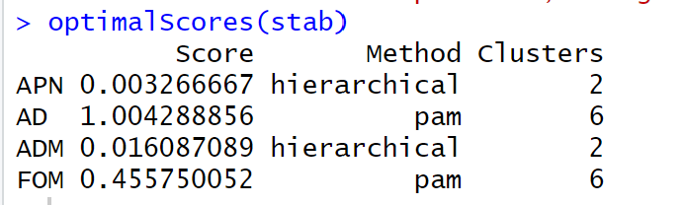

- Reproducibility & GitHub
- Precision Nutrition Interpretation

